Git Installation
Download:
Download the latest version of Git (Ex: Git-1.7.7-preview20111014.exe) and extract full package file.
Installation:
Use the default options for each step. So you will click only Next Button.
Step1:
f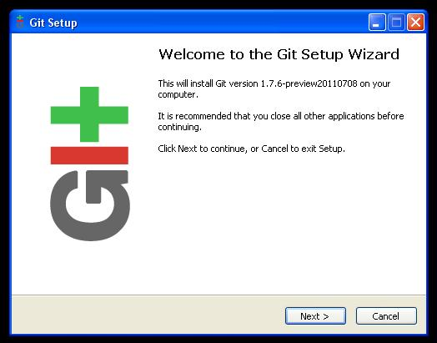

Step2:
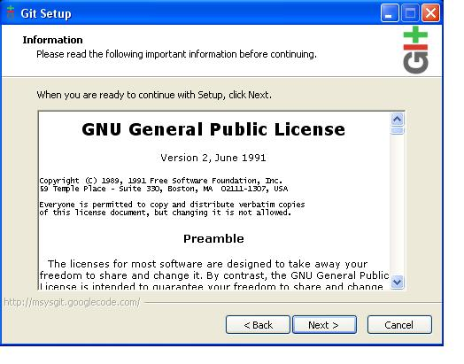
Step3:
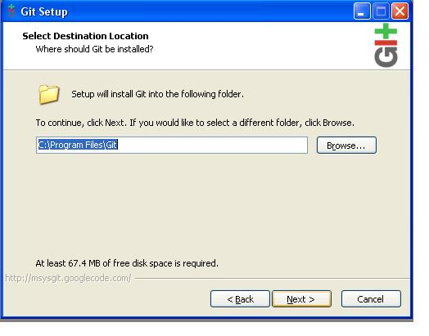
Step4:
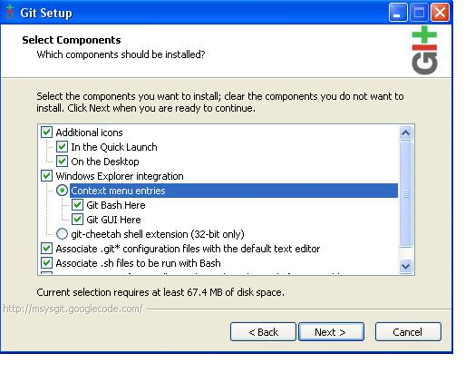
Step5:
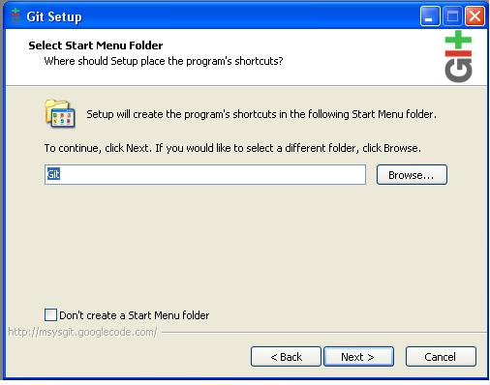
Step6:
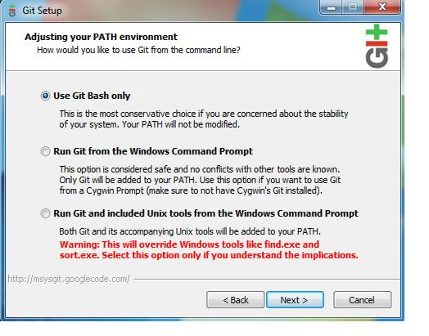
Step7:
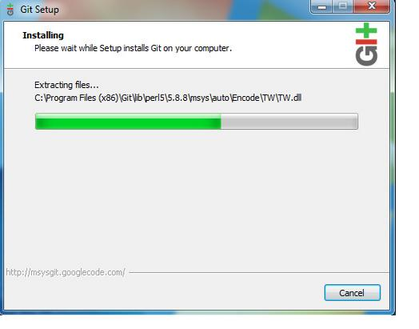
Step8:
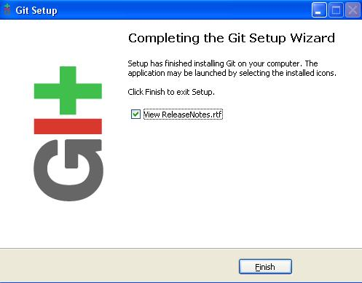

Putty Installation
Download:
Download the latest version of Putty (Ex: putty-0.61-installer.exe) and extract full package file.
Installation:
Use the default options for each step. So you will click only Next Button.
Step 1:
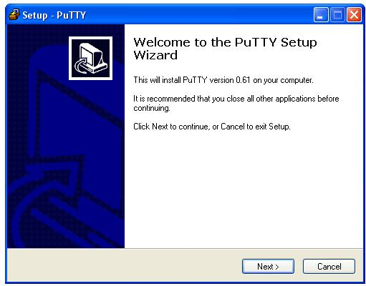
Step 2:
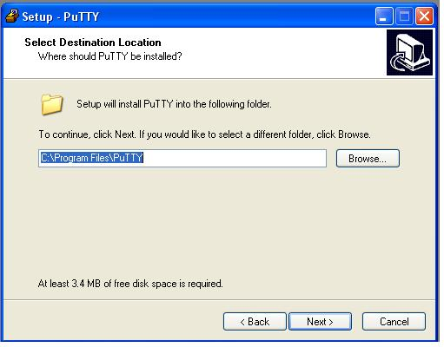
Step 3:
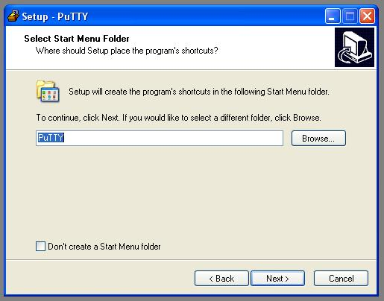
Step 4:
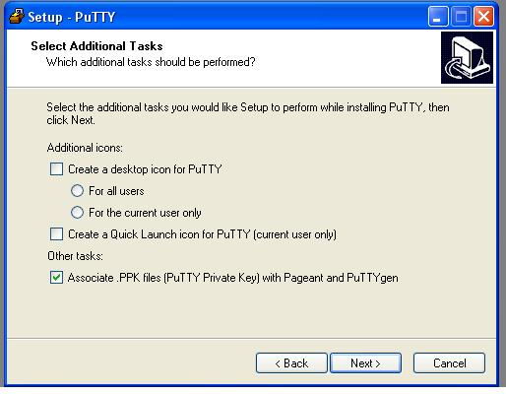
Step 5:
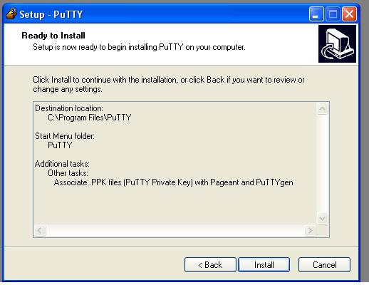
Step 6:
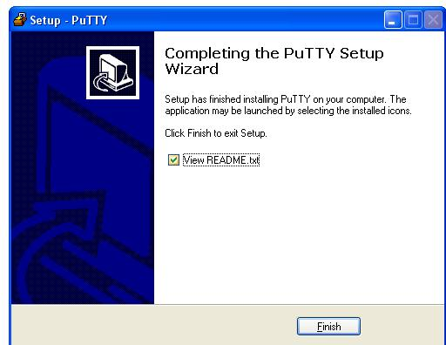

TortoiseGit Installation
Download:
Download the latest version of TortoiseGit (Ex:tortoiset-1.6.5.0(32 bit)) and extract full package file.
Installation:
Use the default options for each step. So you will click only Next Button.
Step 1:
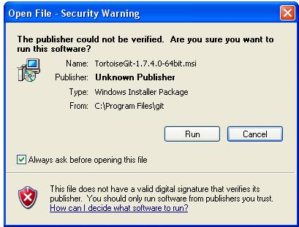

Step 2:
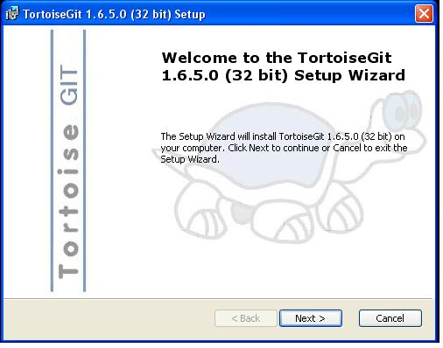
Step 3:
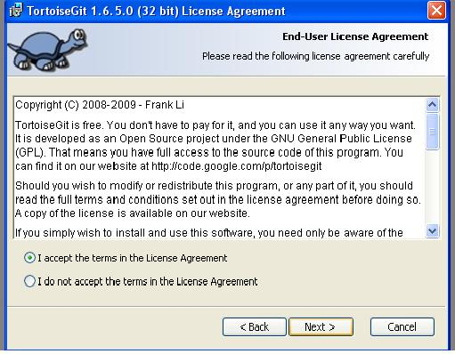
Step 4:
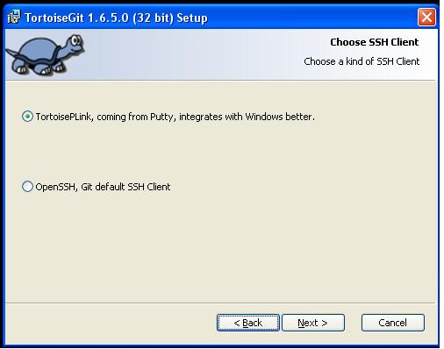

Step 5:
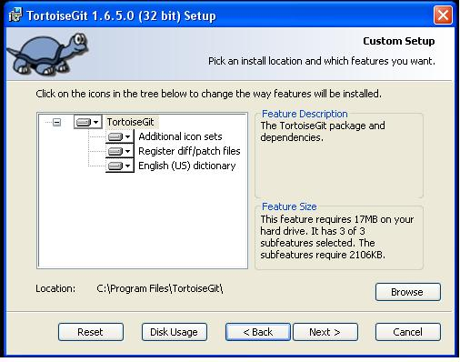
Step 6:
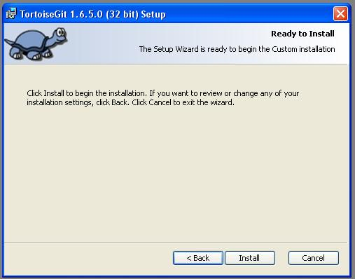
Step 7:
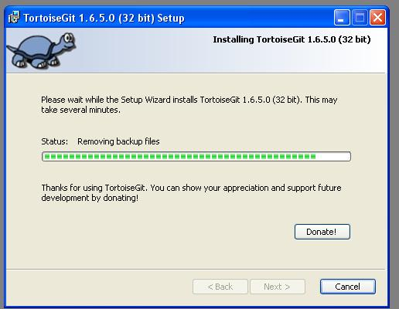
Step 8:
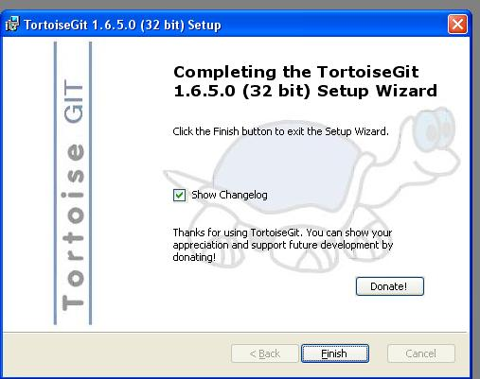
Key Generation TortoiseGit for Git
Step 1:
Open the puttygen form start->TortoiseGit->Puttygen
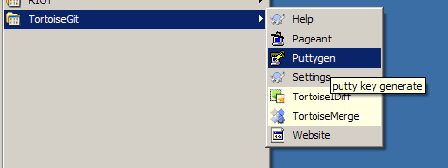

Step 2:
You will go the Key section: Select generate button.
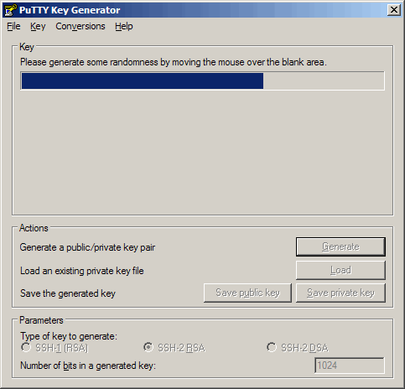

Step 3:
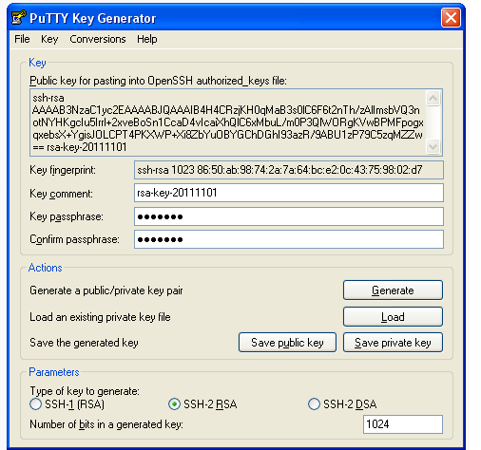

You will go to the Key section: Enter the Key passphrase: your wishes (Ex:test123).
Confirm passphrase: test123.
Then You will go to the Action section: press save private key button.
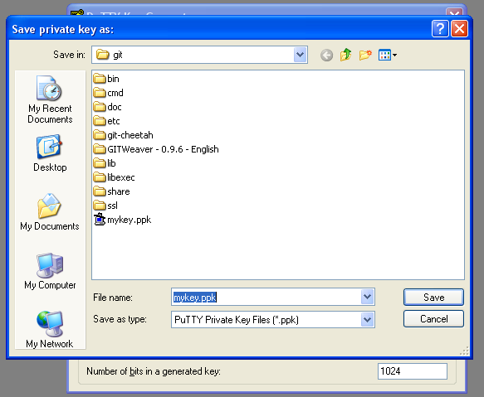
Save the key generation file from your computer. This file is most important so save carefully and click Load Button
Step 4:
Go to Github.com. create your account and login.
Open the Account Settings->SSH Public Keys->Add another public key
Title: your wishes.
Key: public key form previous step.
Details are completed click Add Key Button.
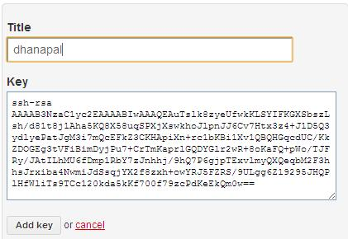
Displaying message Key was successfully added.
Set Up Your Information from Git
- Set your username and email.
Open gitbash from start->All program->git->gitbash.
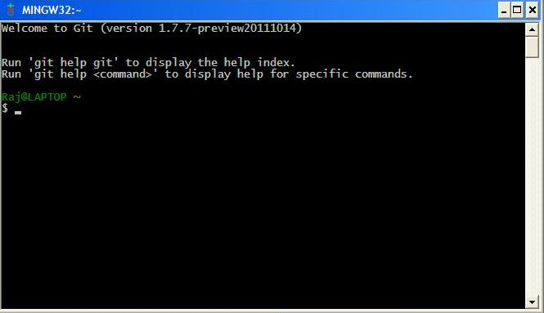
Enter the below code from command prompt
$ git config --global user.name “Firstname Lastname”
$ git config --global user.email “your_email@youremail.com”

- Set your GitHub token.
Some tools connect to GitHub without SSH. To use these tools properly you need to find and configure your API Token.
On the GitHub site Click “Account Settings” > Click “Account Admin.”
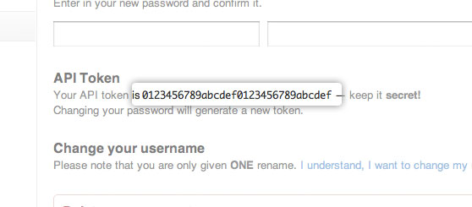
Enter the below code from command prompt
$ git config --global github.user username
$ git config --global github.token 012345678abcdef0123456789abcdef

Git Clone
Locate a repository from the GitHub, from the repository page you will see the the arbitrary URL. It may looks like git@github.com:hideaz2011/We-Share-Articles.git
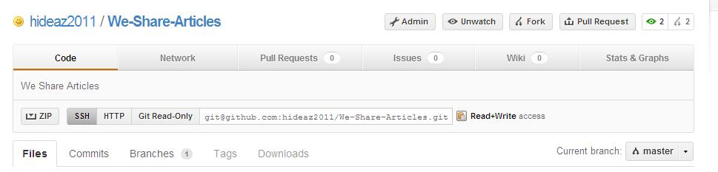
You are going to your working folder... right click -> Git Clone.
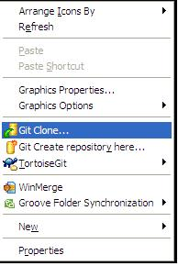

URL: your repository Site.
Directory: Your save dir.
In the "Load Putty Key" field, put your private key file, saved from the PuttyGen in the previous step.
Then click ok button

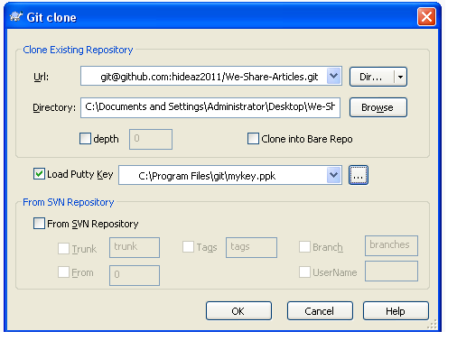
Cloning your file. Finally successfully message displayed.
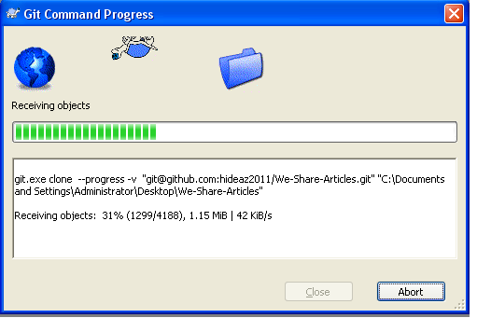

Git Pull
Select your directory folder, sub folder or single file right click->TortoiseGit->Pull.

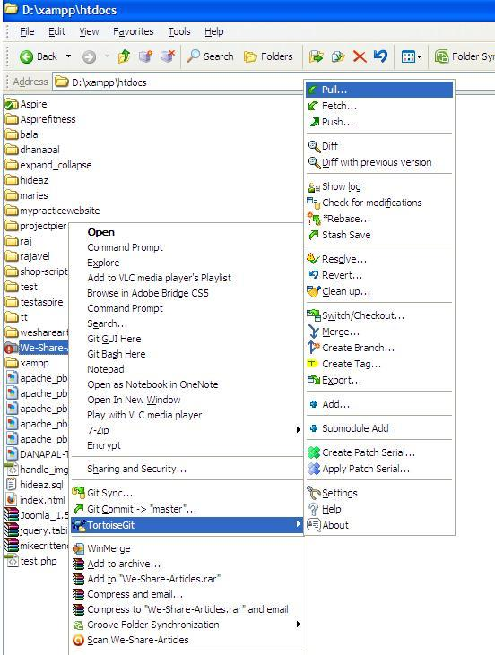
This page was appeared. Use the default value. Then click OK.
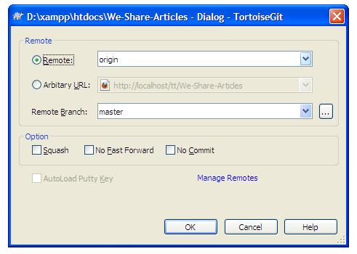
Passphrase key was created previous step (EX: Test123).
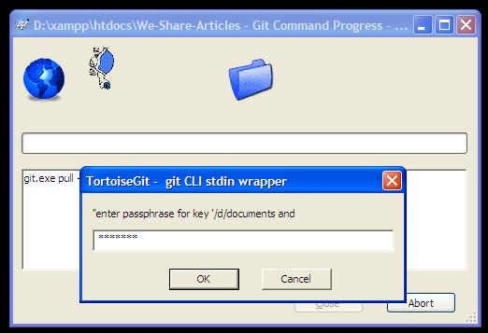

Process was successfully completed.
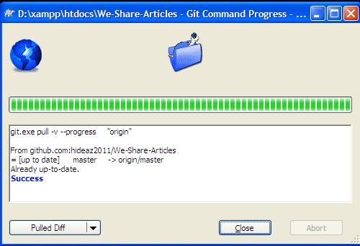

Git commit
Select your directory folder, sub folder or single file right click->Git commit->”master”.
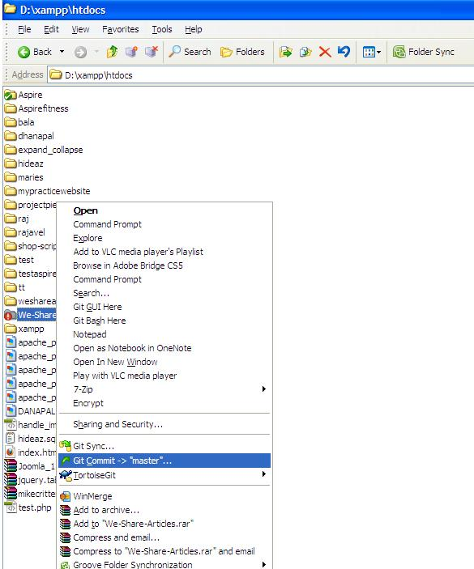
You will indicate the message. Then click OK button
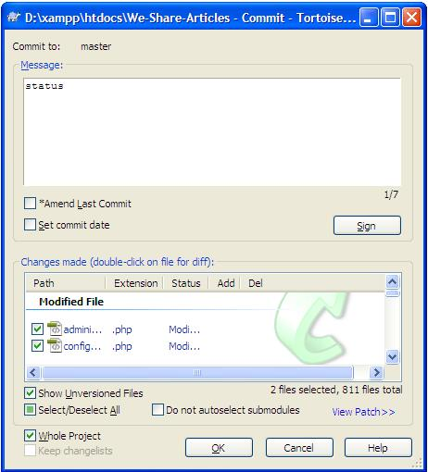

Enter your passphrase key (EX:test123).
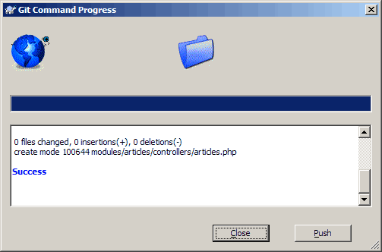

Git Push
Select your directory folder, sub folder or single file right click->TortoiseGit->push.
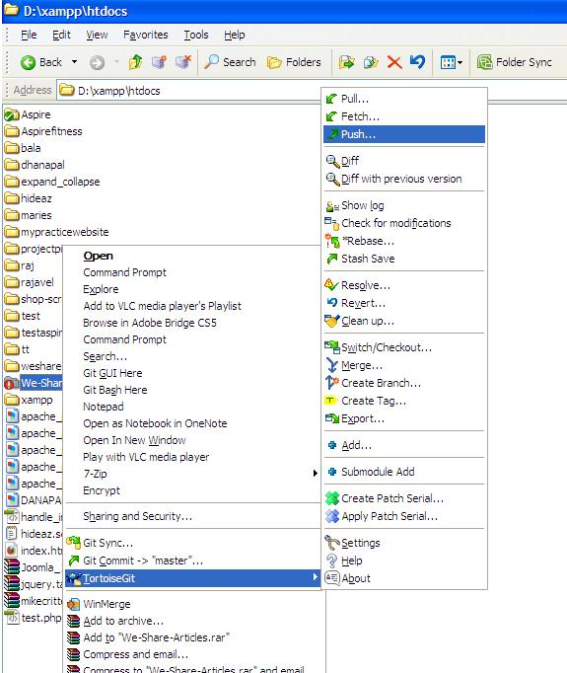

Push Window will be shown. Use default value then click OK button.
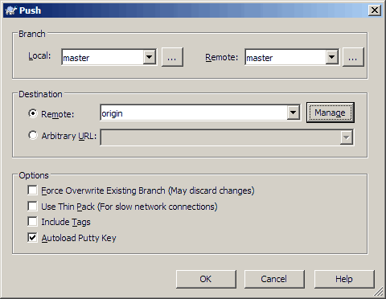
Process complete successfully.
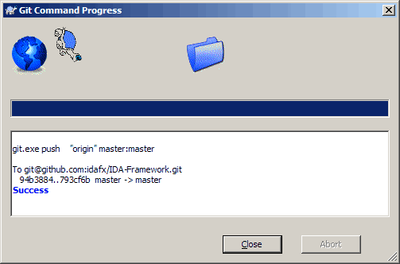

Git Diff
Select your directory folder, sub folder or single file right click->TortoiseGit->Diff.
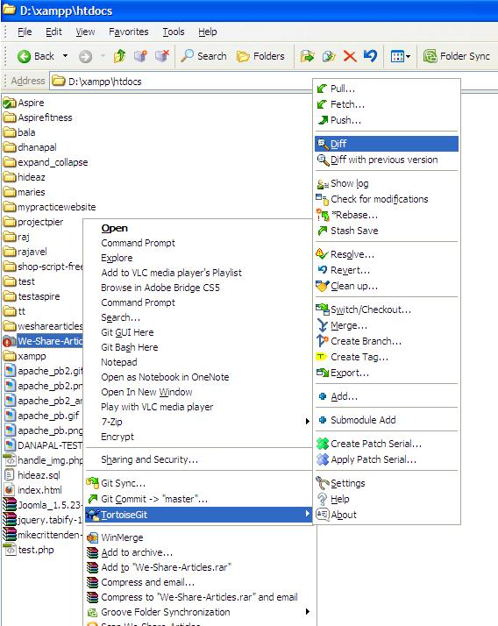

Showing your modified files.
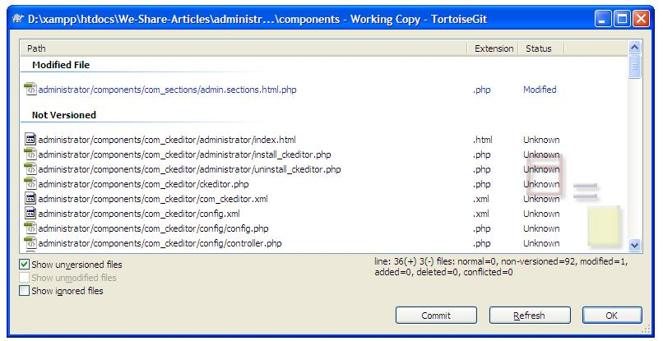
Double click for modified file. Displaying this page.
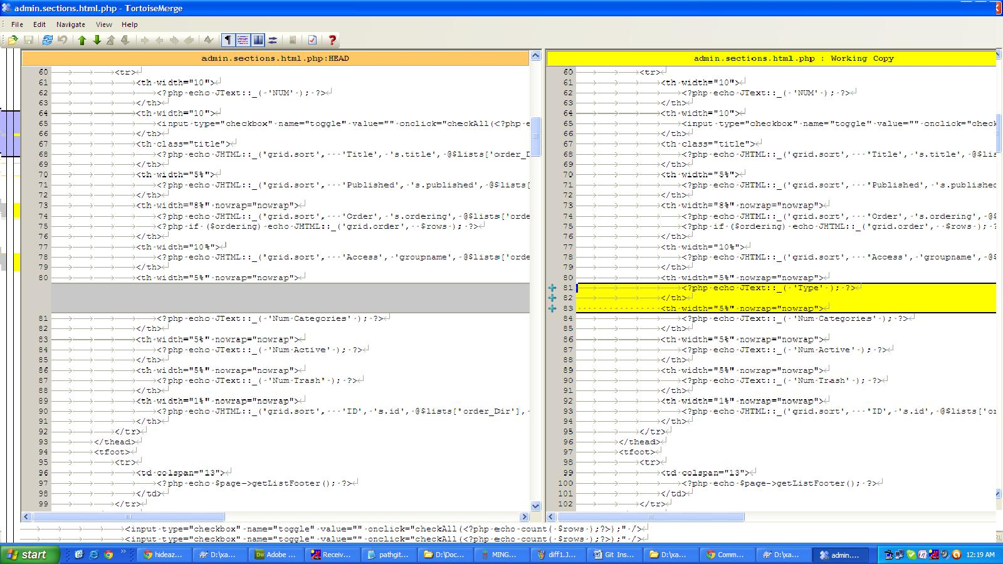
Left side your remote file and right side your working file. Any changes from your working or remote file to change them.
Then click commit button.

Enter your passphrase key (EX:test123).
Click push button.
Push Window will be shown. Use default values then click OK button.
Process complete successfully.

